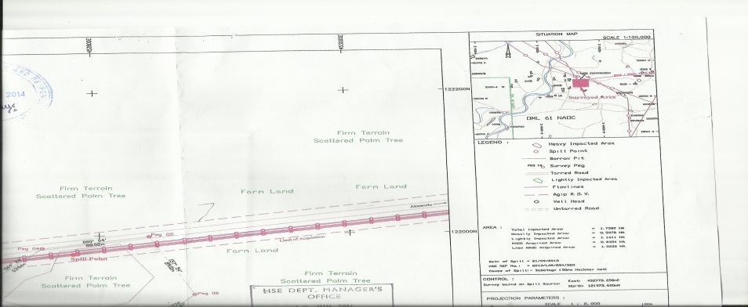
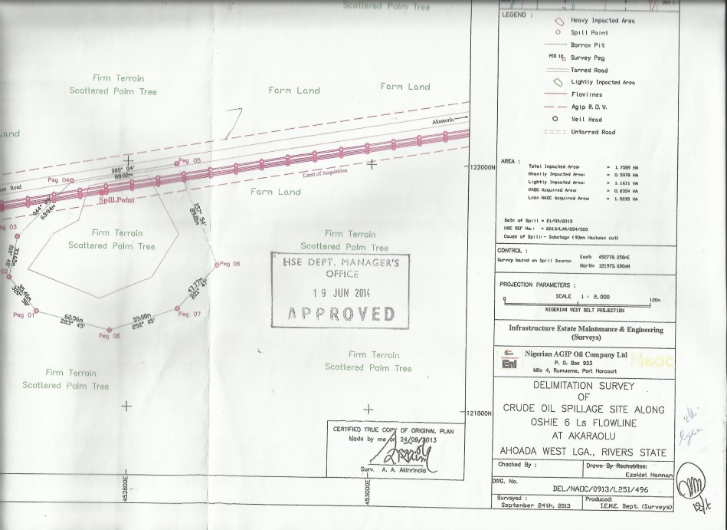
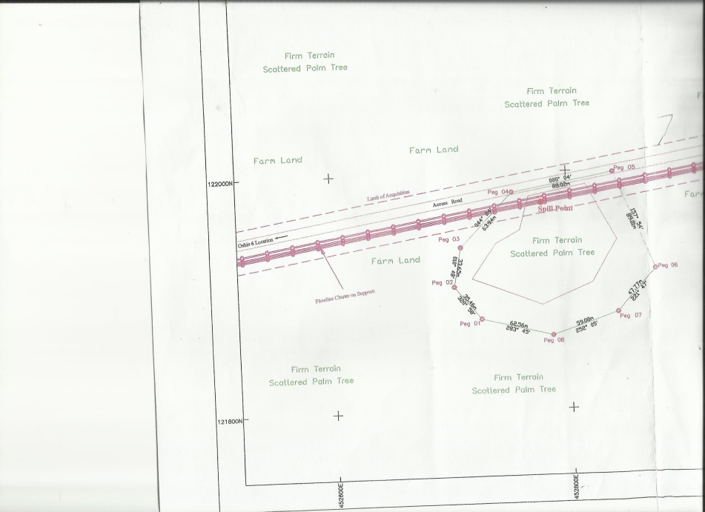
FIG 1 A, B & C: SITE MAP (OSHIE 6 Ls FLOWLINE @ AKARAOLU)

